EXPERIMENT 3: - Create a simple cloud software application for Car Booking Reservation System using any Cloud Service Provider to demonstrate SaaS include the necessary fields such as search for cabs, from, to, rental, out station, Package type, hours/Days etc.

Step 1: - Go to ZOHO.com

Step 2: - Create an account and log into the account

Step 3: - Create an application for the respective requirement

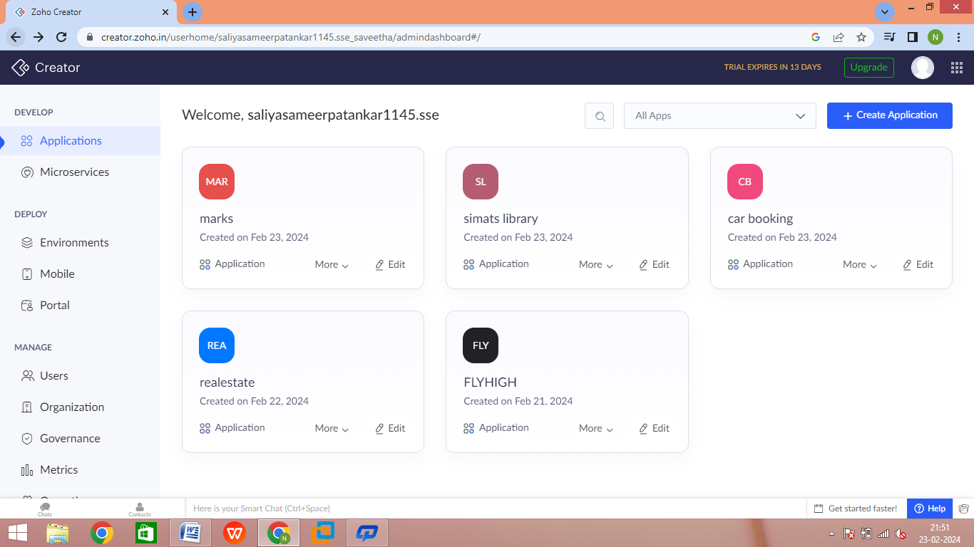

Step 4: - Create the login form

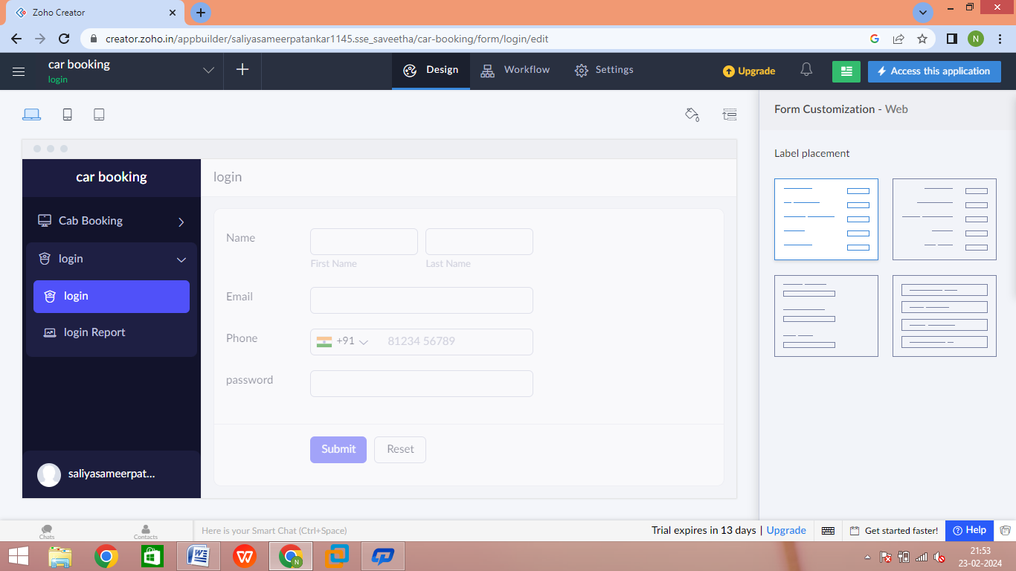

Step 5: - Create the form for cab booking

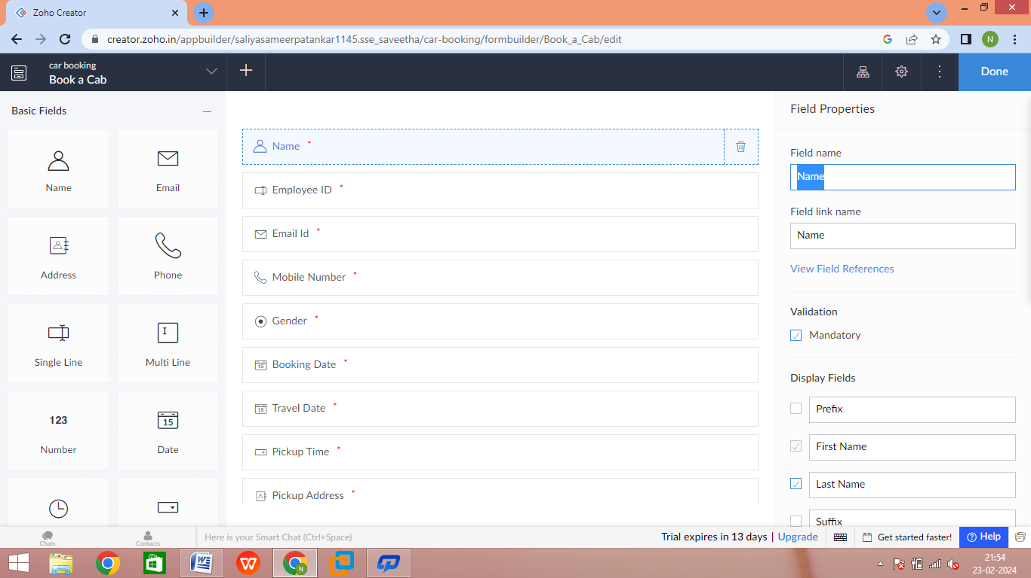

Step 6: - Create a form to display the total and payment proceedings

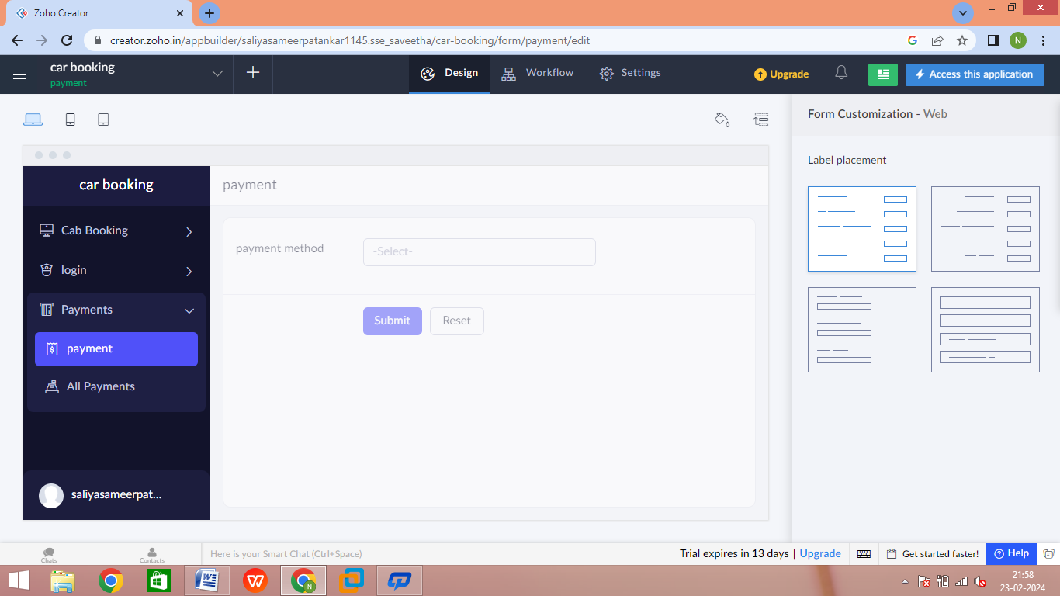

Step 7: - Click the Access development live to see the output

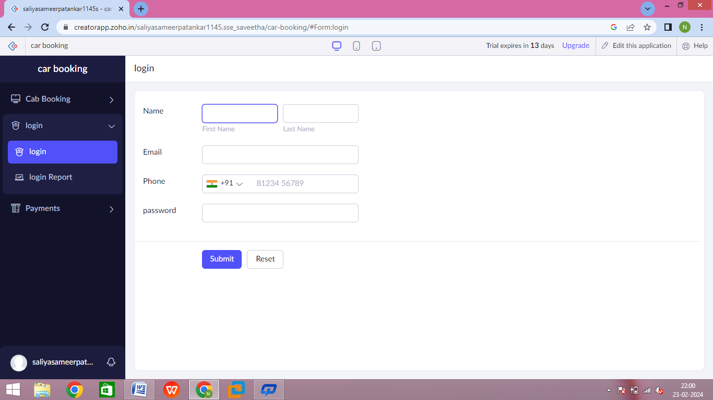

Step 8: - Click the report to see bookings

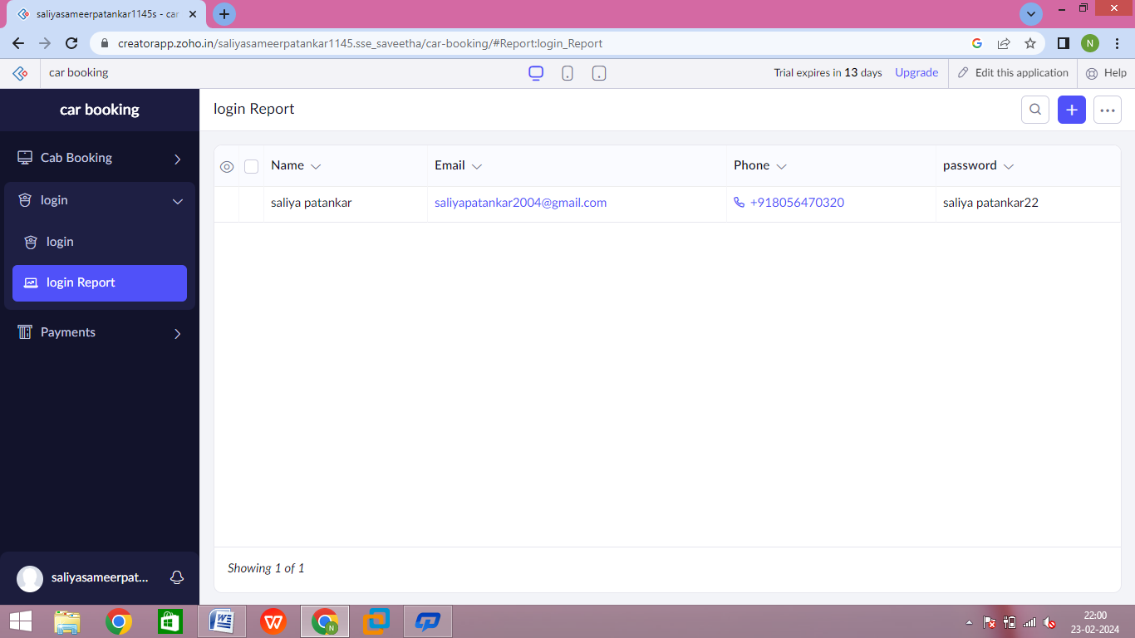

Step 9: - Click the mobile icon to see the output in mobile format

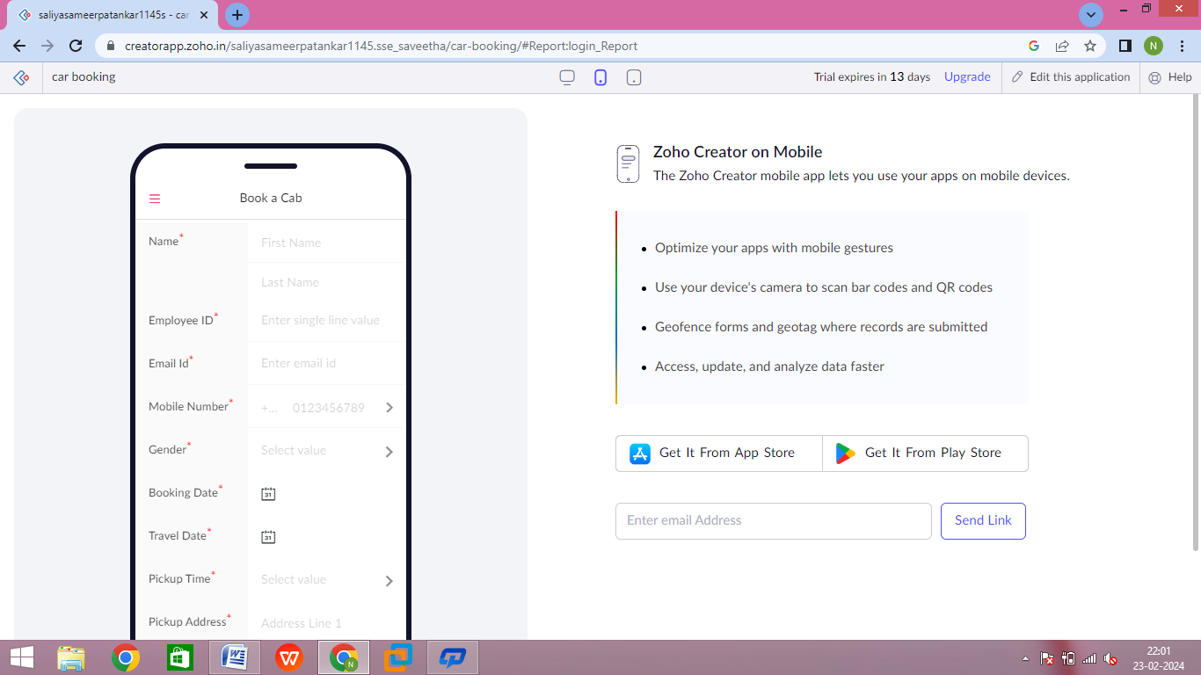

Step 10: - Click the tablet icon to see the output in tablet format

